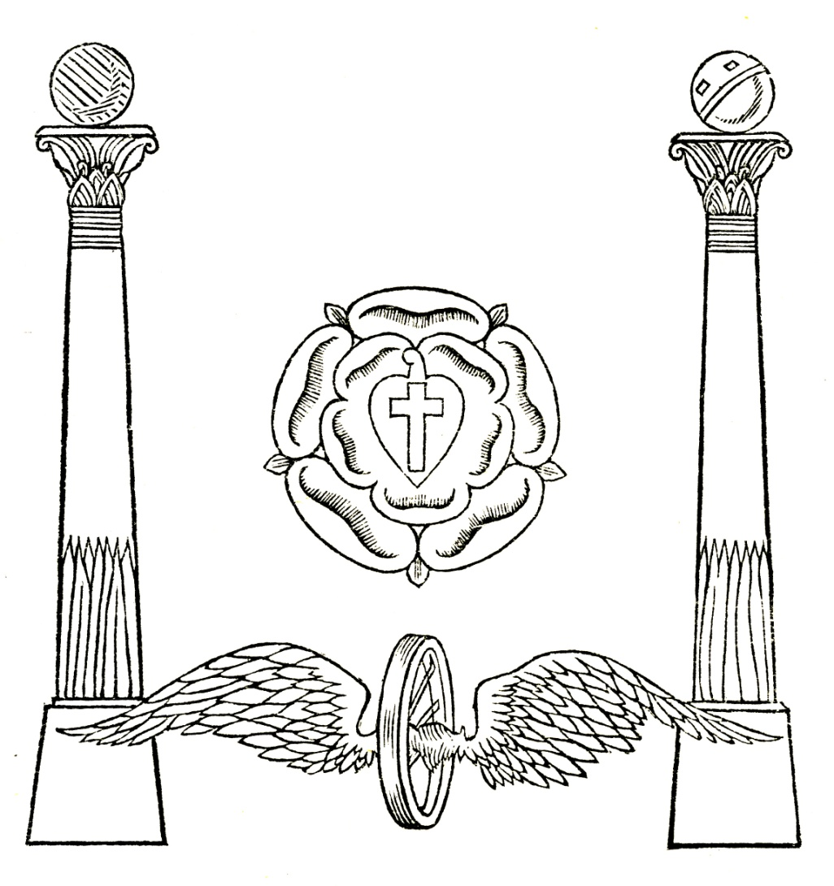

Affirmations
1. Strength.
“I will be strong, brave, persevering in His service.”
2. Wisdom.
“I will attain that intuitional wisdom which can be developed only through perfect love.”
3. Adaptability or Tact.
“I will try to gain the power of saying and doing just the right thing at the right moment-- of meeting each man on his own ground, in order to help him more efficiently.”
4. Beauty and Harmony.
“So far as I can, I will bring beauty and harmony into my life and surroundings, that they may be more worthy of Him; I will learn to see beauty in all Nature, that so I may serve Him better.”
5. Science (detailed knowledge).
“I will gain knowledge and accuracy, that I may devote them to His work.”
6. Devotion.
“I will unfold within myself the mighty power of devotion, that through it I may bring others to Him.”
7. Ordered Service.
“I will so order and arrange my service of God along the lines which He has prescribed, that I may be able fully to take advantage of the loving help which His holy Angels are always waiting to render."
From Leadbeater, C W “The Masters And The Path” Chapter XII The Chohans And The Rays, The Qualities To Be Developed P270
[Editor’s Note: When saying the words “I will …", try to invoke the Will aspect of the Divine Self within by imagining a shaft of white light penetrating through ones mental, emotional and physical vehicles. Some recent authors have taught that affirmations may be spoken in the present tense such as “I am this or that …", however, the means must justify the end, not the other way around. In this sense it is better to be honest and say that we Will realise our potential, rather than to say that we are something which we are not, at least in the outer sense. The scheme of evolutionary law is constantly realising the potential of each being, and as we grow every moment we cannot help but to become that which we think and do.]

“Self reverence, Self knowledge, Self control”
From “Letters from The Masters Of The Wisdom First Series” P151
[Editor’s note: Self is the Âtmâ or Higher Self].

“More radiant than the Sun,
Purer than the Snow,
Subtler than the Ether,
Is the Self, the spirit within my heart.
I am that Self; that Self am I.”
From Leadbeater, Charles Webster “The Masters And The Path” Chapter III The Way To The Master, The Responsibility Of The Teacher P64
[Editor’s note: Self is the Âtmâ or Higher Self. This affirmation and the next may be used as a meditation]

“I am Will-ruled, mentally, emotionally and physically”
From Hodson, Geoffrey “The Yogic Ascent To Spiritual Heights”, Section 7, The Occult Life, Will And Equipoise
[Editor’s Note: When saying the words “I am will-ruled … “ try to invoke the Will aspect of the Divine Self within by imagining a shaft of white light penetrating through ones physical, emotional and mental vehicles.

“All is Joy”
From Scott, Cyril “The Greater Awareness”

“Om Mani Padme Hum” Translated “Oh the Jewel in the Lotus” by Orientalists, esoterically it signifies “O, my God within me”; “I am that I am”; “I am in thee and thou art in me.” It is a Seven syllabled affirmation, with the first syllable as double “A-um”. Padmapâni is the Higher Ego or Manas.
From HPB’s CW XII ES Instructions 1 516-518; Theosophical Glossary, ‘Avalokiteswara’; and see also Talks On The Path Of Occultism II by CWL and AB 68-74

There is a road, steep and thorny, beset with perils of every kind, but yet a road, and it leads to the very heart of the Universe: I can tell you how to find those who will show you the secret gateway that opens inward only, and closes fast behind the neophyte for evermore. There is no danger that dauntless courage cannot conquer; there is no trial that spotless purity cannot pass through; there is no difficulty that strong intellect cannot surmount. For those who win onwards there is reward past all telling—the power to bless and save humanity; for those who fail, there are other lives in which success may come.
From Collected Wrings Of H P Blavatsky Vol XIII P219

From the “Book of Discipline” in the schools of “Dzyan.”
“Behold the truth before you:
A clean life, an open mind, a pure heart, an eager intellect, an unveiled spiritual perception, a brotherliness for one’s co-disciple, a readiness to give and receive advice and instruction, a loyal sense of duty to the Teacher, a willing obedience to the behests of TRUTH, once we have placed our confidence in, and believe that Teacher to be in possession of it; a courageous endurance of personal injustice, a brave declaration of principles, a valiant defence of those who are unjustly attacked, and a constant eye to the ideal of human progression and perfection which the secret science (Gupta-Vidyā) depicts––these are the golden stairs up the steps of which the learner may climb to the Temple of Divine Wisdom.”
From Collected Writings Of H P Blavatsky Vol XII P502-503

“May the Holy Ones, whose pupils you aspire to become, show you the Light you seek, give you the strong aid of their compassion and their wisdom.
There is a peace that passeth understanding; it abides in the hearts of those who live in the Eternal; there is a power that maketh all things new; it lives and moves in those who know the Self as One.
May that peace brood over you, that power uplift you, till you stand where the One Initiator is invoked, till you see His Star shine forth.”
First Ray Benediction By Annie Besant, used in the closing part of the LCC Liturgy

O Hidden Life, Vibrant In Every Atom
O Hidden Light, Shining In Every Creature
O Hidden Love, Embracing All In Oneness
May Each Who Feels Himself As One With Thee
Know He Is Therefore One With Every Other
Original Version By Annie Besant

O Hidden Life, Vibrant In Every Atom
O Hidden Light, Shining In Every Creature
O Hidden Love, Embracing All In Oneness
May All Who Feels Themselves As One With Thee
Know They Are Therefore One With Every Other
Later Variation

Imperil, which attracts danger, is a poison resulting from irritability. ..better to say...
"How beautiful it all is."
From Agni Yoga Stanza15

Healing Affirmations
“May the healing powers of the Lord Christ descend upon <name> and may the Holy Angels encompass <him /her>.”
From Hodson, Geoffrey “Health And Healing”
[Editor’s Note: Imagine the recipient happy and healthy, filled with the light of the holy angels or devas, and radiating their own divine light in all directions. Imagine the light of the Lord pouring down into the heart of the recipient and also radiating out in all directions. Do not focus on any point of injury or illness, but imagine the recipient in perfect health so that the channel of healing energy will vitalise and strengthen rather than give energy to the sickness.

An expansion of the Healing Ritual:
Now for the actual process of spiritual healing, whether the sufferers are present or not. Here is a simple but highly effective method, which may be used either when one is alone or working with a group.
First, have a list of the Christian and surnames of those to be healed. Then, in complete privacy and with the body relaxed, turn the thoughts in powerful concentration to a recognised Healing Source. For most Christians, doubtless, this will be the Lord Christ, the Great Healer of Men. Visualise Him and reverently draw near to Him, seeking to realise His Presence. With half-minute pauses for concentration and visualisation after each phrase, repeat aloud and with powerful intent the following Invocation :
"May the healing power of the Lord Christ descend upon <name>
Here mention the Christian and the surnames of those to be healed, with a five-second pause between each name. During the pause visualise the sufferers as radiantly well and as in the very Presence of the Lord Christ, flooded by His glorious healing power and golden light. After all the names have been mentioned, continue:
"May Christ's healing power descend upon them all and may the Holy Angels encompass them."
After a further pause say:
"May the light of Christ's love enfold them forever. Amen."
Those who will sincerely, selflessly and regularly follow this procedure will indubitably prove to themselves that any reasonably intelligent, unselfish person can heal effectively by the powers of the mind and the Spirit.
From Geoffrey Hodson’s “Theosophy Answers Some Problems Of Life” 1961. (p 187-8), from Talks On Radio 2GB, 1951

Creativity Affirmations

Exercise For Creative Inspiration:
Relax the body and imagine the whole of the Aura suffused by a pale but intense golden light like that of the sun. Hold this thought for a minute or two before starting artistic work.
This exercise tends to purify the subtler bodies and render them more receptive to impressions from the higher planes.
From Cyril Scott

