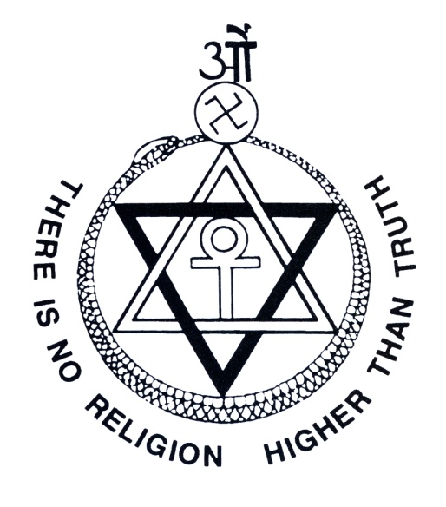

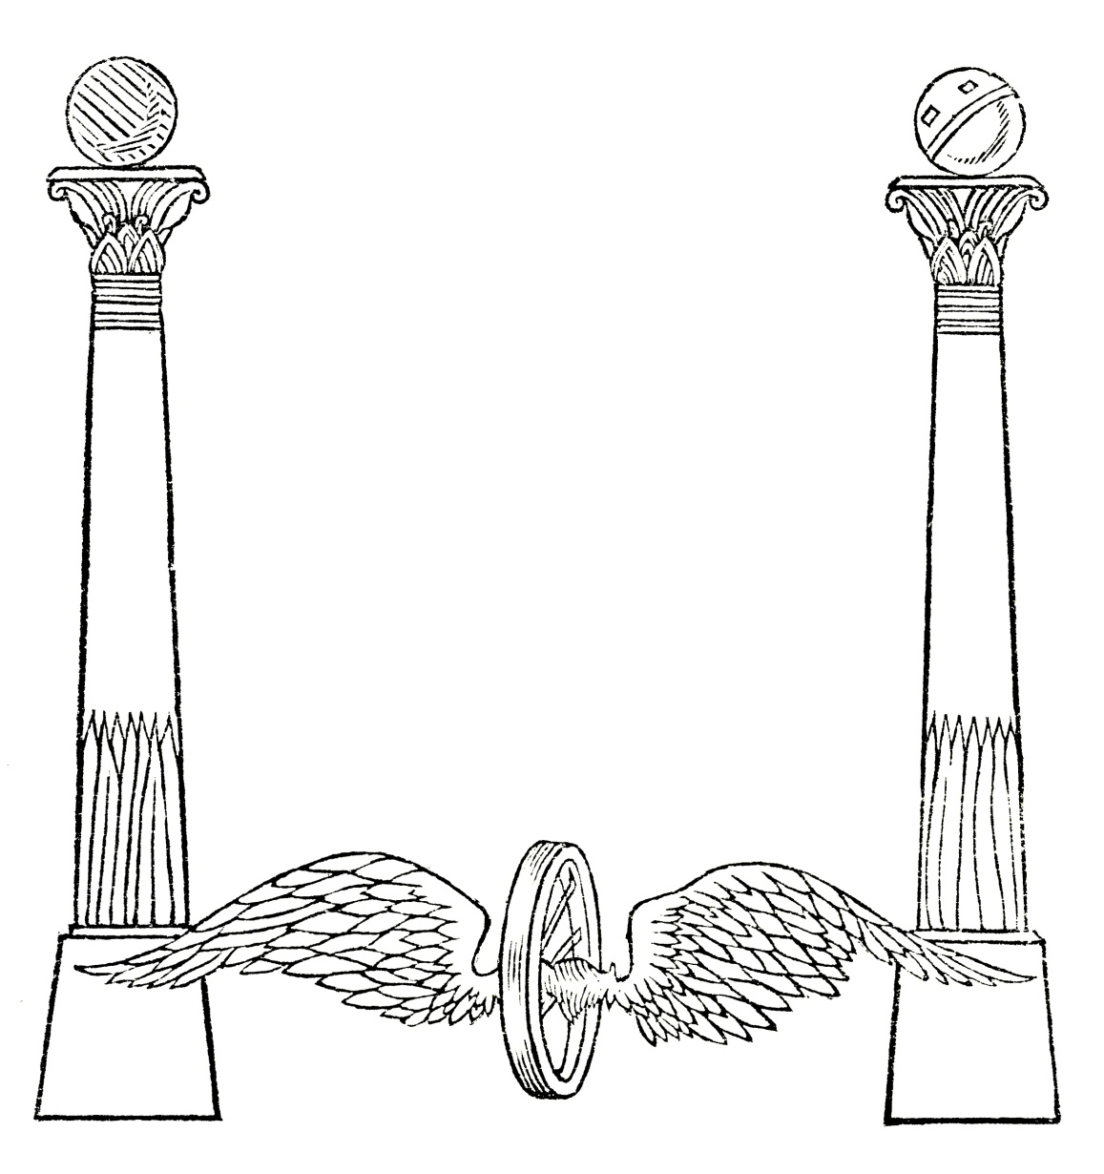

Three Objects of The Theosophical Society

To form a nucleus of the Universal Brotherhood of Humanity without distinction of race, creed, sex, caste or colour

To encourage the study of comparative religion, philosophy and science

To investigate the unexplained laws of nature and the powers latent in Man

These international objects underwent several revisions before being adopted in its present form by the General Council in 1896.
The word ‘brotherhood’ reflects the unity of life and is inclusive of all genders and all people, being free of the distinctions as shown.
The word ‘Man’ in the third object has a technical meaning in metaphysics, referring to collective degrees of consciousness expressed through subtle vehicles of matter—expressed at the Temple at Delphi as ‘Oh man, know thyself, and thou shalt know the Universe and the gods’. It is etymologically derived from a Proto-Indo-European root meaning ‘thinker’; is related to the sanskrit words Manas, meaning ‘mind’ and also Manu, the human progenitor of all humanity; Mahat ‘divine mind’; and Men ‘to think’, the basis of the words mental, manage etc; and therefore here is inclusive of ALL people. In Australia, the objects are generally printed with the expression ‘the human being’ as a substitution for the word ‘Man’.

Theosophy
The Theosophical Society was founded in November 1875 by Colonel Henry Steel Olcott, voted by the members as President for life, Helena Petrovna Blavatsky and William Quan Judge, along with several other people present.
Theosophy, derived from the Greek word ‘Theo’, God or Divine and also ‘Sophia’, wisdom, meaning Divine Wisdom or the Wisdom of the Divine. It is the root and essence of every noble and good religion, philosophy and teaching, and is the inheritance of every human being.
Sometimes known as the Wisdom-Religion or the Wisdom-Tradition, its creed is Loyalty to Truth and its ritual ‘To honour every truth by use’.
The Theosophical Society was organised as a philanthropic and scientific body to promulgate the Theosophical doctrines and to promote the Theosophic life. It is a living experiment formed to encourage practical altruism, to fan within the hearts of all who come into contact with its members the idea of brotherhood, born from the realisation of the unity of all life. Its members are each in sympathy with at least one of the three objects of the society.
The highest ideal is found in the name of the Society. Below that in importance stands the Three Objects, the means to achieve Theosophy (Divine Wisdom) as suggested methods of work. Following that is another class of ideals, important Resolutions that do not stand alone or apart from the other aims and goals of the Theosophical Society. These may be seen as the culmination and perhaps synthesis of very many ideas contributed through the Theosophical Society (TS) up to the time each Resolution was made.

Freedom Of Thought
“As the Theosophical Society has spread far and wide over the world, and as members of all religions have become members of it without surrendering the special dogmas, teachings and beliefs of their respective faiths, it is thought desirable to emphasise the fact that there is no doctrine, no opinion, by whomsoever taught or held, that is in any way binding on any member of the Society, none which any member is not free to accept or reject. Approval of its three Objects is the sole condition of membership.
No teacher, or writer, from H.P. Blavatsky onwards, has any authority to impose his or her teachings or opinions on members. Every member has an equal right to follow any school of thought, but has no right to force the choice on any other. Neither a candidate for any office nor any voter can be rendered ineligible to stand or to vote, because of any opinion held, or because of membership in any school of thought. Opinions or beliefs neither bestow privileges nor inflict penalties.
The Members of the General Council earnestly request every member of the Theosophical Society to maintain, defend and act upon these fundamental principles of the Society, and also fearlessly to exercise the right of liberty of thought and of expression thereof, within the limits of courtesy and consideration for others.”

Resolution passed by the General Council of The Theosophical Society, 1924.

Freedom Of The Society
“The Theosophical Society, while cooperating with all other bodies whose aims and activities make such cooperation possible, is and must remain an organisation entirely independent of them, not committed to any objects save its own, and intent on developing its own work on the broadest and most inclusive lines, so as to move towards its own goal as indicated in and by the pursuit of those objects and that Divine Wisdom which in the abstract is implicit in the title, The Theosophical Society.
Since Universal Brotherhood and the Wisdom are undefined and unlimited, and since there is complete freedom for each and every member of the Society in thought and action, the Society seeks ever to maintain its own distinctive and unique character by remaining free of affiliation or identification with any other organisation.”

Resolution passed by the General Council of The Theosophical Society, 1949

The idea that the Three Objects are subject to the name of the Society, which is “Theosophical”, is made very clear in the “Freedom Of The Society” Resolution, passed by the General Council in 1949. The Resolution points out that “it is not committed to any objects save its own, and intent on developing its own work on the broadest and most inclusive lines”. It goes on by saying “so as to move towards its own goal as indicated in and by the pursuit of those objects and that Divine Wisdom which in the abstract is implicit in the title, The Theosophical Society”. Therefore, ‘Theosophy’ is the vision. The Three Objects are aspects of a mission statement, or qualitative tools in the service of attaining Divine Wisdom. The character of the work carried out by Theosophists inherits this vision, and hence Theosophy becomes both an inspiration and a goal. It is a star in the distance to draw out ones highest qualities and also an unfolding plan in which to discover and find ones purpose.
Yet just as the TS operates under the guiding light of the Three Objects, so in turn can this Resolution, the “Freedom of The Society” best be read and interpreted when it is blended into, and brought under the broad umbrella of, the Three Objects.

The Basic Truths Of Religion
“Theosophy, the Divine Wisdom, is the root of all the great religions, living and dead; all are branches of that ever-living Tree of Life, with its root in Heaven, the leaves of which are for the healing of the nations of the world. Each special religion brings out and emphasises some special aspect of the Truth, necessary for the evolution of humanity during the age it opens, and shapes the civilisation of that age, enriching the religious, moral and cultural heritage of the human race.
The World Religion, of which all special religions are integral parts—whether or not they recognise their places in the World Order—declares :
1. There is one transcendent Self-Existent Life, eternal, all-pervading, all-sustaining, whence all worlds derive their several lives, whereby and wherein all things which exist live and move and have their being.
2. For our world this Life is immanent, and is manifested as the Logos, the Word, worshipped under different Names, in different religions, but ever recognised as the One Creator, Preserver and Regenerator.
3. Under this Logos or Life, our world is ruled and guided by a Hierarchy of the Logos’ Elder Children, variously called Rishis, Sages, Saints, among whom are the World-Teachers, who for each age re-proclaim the essential truths of religion and morality in a form suited to the age; this Hierarchy is aided in its work by the hosts of Beings—again variously named, Devas, Angels, Shining Ones—discharging functions recognised in all religions.
4. Human beings form one order of the creatures evolving on this earth, and each human being evolves by successive life-periods, gathering experiences and building them into character, reaping always as each one sows, until one has learned the lessons taught in the three worlds—the earth, the intermediate state and the heavens—in which a complete life-period is passed, and has reached human perfection, when one enters the company of ‘just men made perfect’, that rules and guides the evolving lives in all stages of their growth.
These are the Basic Truths of the World Religion, of which all religions are specialised branches; to proclaim and teach these the Theosophical Society was founded and exists.
The World Religion will thus help in preparing the way for the Coming of the World-Teacher, who shall give to the Basic Truths the form suited to the age the Great One will open—the Age of Brotherhood.
The Theosophical Society admits to its fellowship all who desire to enter it, whether or not they hold any of these basic truths, or belong to any religion or to none, since all belong to the Universal Brotherhood of Humanity, of which it is a nucleus.”

Drawn from a Resolution passed by the General Council of The Theosophical Society, 1925. (See The Theosophist March 1926, Pages 754-755 for the original text.)

It is important to understand that the term World-Teacher refers to an office or role and not simply to a particular being or name. The word ‘Christ’ means ‘Anointed One’, similarly the word ‘Buddha’ means ‘Enlightened’ or ‘Awakened One’, and Krishna means ‘Dark God’; all of which represent titles, and are not personal names. Like God or Logos, which, when free of superstition and anthropomorphism, has many names for the One ‘in which we live and move and have our being’, so does the World-Teacher have many names. As there have been avatars like Krishna, Buddha and Christ in the past, there will be avatars like Krishna, Buddha and Christ in the future.

What Is Theosophy?
An article By H P Blavatsky
[From ‘The Theosophist’, Volume I, No 1, October, 1879, Pages 2 – 5]
This question has been so often asked, and misconception so widely prevails, that the editors of a journal devoted to an exposition of the world’s Theosophy would be remiss were its first number issued without coming to a full understanding with their readers. But our heading involves two further queries: What is the Theosophical Society; and what are the Theosophists? To each an answer will be given.
According to lexicographers, the term theosophia is composed of two Greek words—theos, “god,” and sophos, “wise.” So far, correct. But the explanations that follow are far from giving a clear idea of Theosophy. Webster defines it most originally as “a supposed intercourse with God and superior spirits, and consequent attainment of superhuman knowledge, by physical processes, as by the theurgic operations of some ancient Platonists, or by the chemical processes of the German fire-philosophers.”
This, to say the least, is a poor and flippant explanation. To attribute such ideas to men like Ammonius Saccas, Plotinus, Iamblichus, Porphyry, Proclus—shows either intentional misrepresentation, or Mr. Webster’s ignorance of the philosophy and motives of the greatest geniuses of the later Alexandrian School. To impute to those whom their contemporaries as well as posterity styled “theodidaktoi,” god-taught—a purpose to develop their psychological, spiritual perceptions by “physical processes,” is to describe them as materialists. As to the concluding fling at the fire-philosophers, it rebounds from them to fall home among our most eminent modern men of science; those, in whose mouths the Rev. James Martineau places the following boast: “matter is all we want; give us atoms alone, and we will explain the universe.”
Vaughan offers a far better, more philosophical definition. “A Theosophist,” he says—“is one who gives you a theory of God or the works of God, which has not revelation, but an inspiration of his own for its basis.” In this view every great thinker and philosopher, especially every founder of a new religion, school of philosophy, or sect, is necessarily a Theosophist. Hence, Theosophy and Theosophists have existed ever since the first glimmering of nascent thought made man seek instinctively for the means of expressing his own independent opinions.
There were Theosophists before the Christian era, notwithstanding that the Christian writers ascribe the development of the Eclectic theosophical system, to the early part of the third century of their Era. Diogenes Laërtius traces Theosophy to an epoch antedating the dynasty of the Ptolemies; and names as its founder an Egyptian Hierophant called Pot-Amun, the name being Coptic and signifying a priest consecrated to Amun, the god of Wisdom.
But history shows it revived by Ammonius Saccas, the founder of the Neo-Platonic School. He and his disciples called themselves “Philaletheians”—lovers of the truth. While others termed them the “Analogists,” on account of their method of interpreting all sacred legends, symbolical myths and mysteries, by a rule of analogy or correspondence, so that events which had occurred in the external world were regarded as expressing operations and experiences of the human soul.
It was the aim and purpose of Ammonius to reconcile all sects, peoples and nations under one common faith—a belief in one Supreme, Eternal, Unknown, and Unnamed Power, governing the Universe by immutable and eternal laws.
His object was to prove a primitive system of Theosophy, which at the beginning was essentially alike in all countries; to induce all men to lay aside their strives and quarrels, and unite in purpose and thought as the children of one common mother; to purify the ancient religions, by degrees corrupted and obscured, from all dross of human element, by uniting and expounding them upon pure philosophical principles. Hence, the Buddhistic, Vedantic and Magian, or Zoroastrian, systems were taught in the Eclectic Theosophical School along with all the philosophies of Greece. Hence also, that pre-eminently Buddhistic and Indian feature among the ancient Theosophists of Alexandria, of due reverence for parents and aged persons; a fraternal affection for the whole human race; and a compassionate feeling for even the dumb animals.
While seeking to establish a system of moral discipline which enforced upon people the duty to live according to the laws of their respective countries; to exalt their minds by the research and contemplation of the one Absolute Truth; his chief object in order, as he believed, to achieve all others, was to extract from the various religious teachings, as from a many-chorded instrument, one full and harmonius melody, which would find response in every truth-loving heart.
Theosophy is, then, the archaic Wisdom-Religion, the esoteric doctrine once known in every ancient country having claims to civilization.
This “Wisdom” all the old writings show us as an emanation of the divine Principle; and the clear comprehension of it is typified in such names as the Indian Budha, the Babylonian Nebo, the Thoth of Memphis, the Hermes of Greece; in the appelations, also, of some goddesses—Metis, Neitha, Athena, the Gnostic Sophia, and finally—the Vedas, from the word “to know.” Under this designation, all the ancient philosophers of the East and West, the Hierophants of old Egypt, the Rishis of Aryavarta, the Theodidaktoi of Greece, included all knowledge of things occult and essentially divine. The Mercavah of the Hebrew Rabbis, the secular and popular series, were thus designated as only the vehicle, the outward shell which contained the higher esoteric knowledge. The Magi of Zoroaster received instruction and were initiated in the caves and secret lodges of Bactria; the Egyptian and Grecian hierophants had their aporrhêta, or secret discourses, during which the Mystês became an Epoptês—a Seer.
The central idea of the Eclectic Theosophy was that of a single Supreme Essence, Unknown and Unknowable—for—“How could one know the knower?” as enquires Brihadaranyaka Upanishad. Their system was characterized by three distinct features:
the theory of the above-named Essence;
the doctrine of the human soul—an emanation from the latter, hence of the same nature;
and its theurgy.
It is this last science which has led the Neo-Platonists to be so misrepresented in our era of materialistic science. Theurgy being essentially the art of applying the divine powers of man to the subordination of the blind forces of nature, its votaries were first termed magicians—a corruption of the word “Magh,” signifying a wise, or learned man, and—derided. Skeptics of a century ago would have been as wide of the mark if they had laughed at the idea of a phonograph or a telegraph. The ridiculed and the “infidels” of one generation generally become the wise men and saints of the next.
As regards the Divine Essence and the nature of the soul and spirit, modern Theosophy believes now as ancient Theosophy did. The popular Diu of the Aryan nations was identical with the Iao of the Chaldeans, and even with the Jupiter of the less learned and philosophical among the Romans; and it was just as identical with the Jahve of the Samaritans, the Tiu or “Tuisto” of the Northmen, the Duw of the Britons, and the Zeus of the Thracians.
As to the Absolute Essence, the One and All—whether we accept the Greek Pythagorean, the Chaldean Kabalistic, or the Aryan philosophy in regard to it, it will all lead to one and the same result. The Primeval Monad of the Pythagorean system, which retires into darkness and is itself Darkness (for human intellect) was made the basis of all things; and we can find the idea in all its integrity in the philosophical systems of Leibnitz and Spinoza.
Therefore, whether a Theosophist agrees with the Kabala which, speaking of En-Soph, propounds the query: “Who, then, can comprehend It, since It is formless, and Non-Existent?”—or, remembering that magnificent hymn from the Rig-Veda (Hymn 129th, Book 10th)— enquires:
“Who knows from whence this great creation sprang?
Whether his will created or was mute.
He knows it—or perchance even He knows not.”
Or, again, accepts the Vedantic conception of Brahma, who in the Upanishads is represented as “without life, without mind, pure,” unconscious, for—Brahma is “Absolute Consciousness.” Or, even finally, siding with the Svâbhâvikas of Nepal, maintains that nothing exists but “Svabhavat” (substance or nature) which exists by itself without any creator—any one of the above conceptions can lead but to pure and absolute Theosophy.
That Theosophy which prompted such men as Hegel, Fichte and Spinoza to take up the labours of the old Grecian philosophers and speculate upon the One Substance—the Deity, the Divine All proceeding from the Divine Wisdom—incomprehensible, unknown, and unnamed—by any ancient or modern religious philosophy, with the exception of Christianity and Mohammedanism.
Every Theosophist, then, holding to a theory of the Deity “which has not revelation, but an inspiration of his own for its basis,” may accept any of the above definitions or belong to any of these religions, and yet remain strictly within the boundaries of Theosophy. For the latter is belief in the Deity as the ALL, the source of all existence, the infinite that cannot be either comprehended or known, the universe alone revealing It, or, as some prefer it, Him, thus giving a sex to that, to anthropomorphize which is blasphemy. True, Theosophy shrinks from brutal materialization; it prefers believing that, from eternity retired within itself, the Spirit of the Deity neither wills nor creates; but that, from the infinite effulgency everywhere going forth from the Great Centre, that which produces all visible and invisible things is but a Ray containing in itself the generative and conceptive power, which, in its turn produces that which the Greeks called Macrocosm, the Kabalists Tikkun or Adam Kadmon—the archetypal man, and the Aryans Purusha, the manifested Brahm, or the Divine Male.
Theosophy believes also in the Anastasis or continued existence, and in transmigration (evolution) or a series of changes in the soul* which can be defended and explained on strict philosophical principles; and only by making a distinction between Paramâtma (transcendental, supreme soul) and Jivâtma (animal, or conscious soul) of the Vedantins.
––––––––––
* Note—In a series of articles entitled “The World’s Great Theosophists,” we intend showing that from Pythagoras, who got his wisdom in India, down to our best known modern philosophers, and theosophists—David Hume, and Shelley, the English poet the Spiritists of France included—many believed and yet believe in metempsychosis or reincarnation of the soul; however unelaborated the system of the Spiritists may fairly be regarded.
[Such a series of articles by this title was never written by H.P.B., though other articles and books containing these themes and ideas were certainly written under a variety of headings, particularly The Secret Doctrine, Isis Unveiled, The Collected Writings Volumes 1 to 15 and The Theosophical Glossary—Compiler.]
––––––––––
To fully define Theosophy, we must consider it under all its aspects. The interior world has not been hidden from all by impenetrable darkness. By that higher intuition acquired by Theosophia—or God-knowledge, which carries the mind from the world of form into that of formless spirit, man has been sometimes enabled in every age and every country to perceive things in the interior or invisible world.
Hence, the “Samadhi,” or Dyan Yog Samadhi, of the Hindu ascetics; the “Daïmonion-photi,” or spiritual illumination, of the Neo-Platonists; the “Sidereal confabulation of souls,” of the Rosicrucians or Fire-philosophers; and, even the ecstatic trance of mystics and of the modern mesmerists and spiritualists, are identical in nature, though various as to manifestation. The search after man’s diviner “self,” so often and so erroneously interpreted as individual communion with a personal God, was the object of every mystic, and belief in its possibility seems to have been coëval with the genesis of humanity—each people giving it another name.
Thus Plato and Plotinus call “Noëtic work” that which the Yogis and the Srotriya term Vidya. “By reflection, self-knowledge and intellectual discipline, the soul can be raised to the vision of eternal truth, goodness, and beauty—that is, to the Vision of God—this is the epopteia,” said the Greeks. “To unite one’s soul to the Universal Soul,” says Porphyry, “requires but a perfectly pure mind. Through self-contemplation, perfect chastity, and purity of body, we may approach nearer to It, and receive, in that state, true knowledge and wonderful insight.” And Swami Dayânund Saraswati, who has read neither Porphyry nor other Greek authors, but who is a thorough Vedic scholar, says in his Veda-Bhâshya (upâsanâ prakara ank. 9)—“To obtain Diksha (highest initiations) and Yog, one has to practice according to the rules . . . The soul in human body can perform the greatest wonders by knowing the Universal Spirit (or God) and acquainting itself with the properties and qualities (occult) of all the things in the universe. A human being (a Dikshita or initiate) can thus acquire a power of seeing and hearing at great distances.” Finally, Alfred R. Wallace, F. R. S., a spiritualist and yet a confessedly great naturalist, says, with brave candour: “It is ‘spirit’ that alone feels, and perceives, and thinks—that acquires knowledge, and reasons and aspires . . . there not unfrequently occur individuals so constituted that the spirit can perceive independently of the corporeal organs of sense, or can, perhaps, wholly or partially, quit the body for a time and return to it again . . . the spirit . . . communicates with spirit easier than with matter.”
We can now see how, after thousands of years have intervened between the age of the Gymnosophists* and our own highly civilized era, notwithstanding, or, perhaps, just because of, such an enlightenment which pours its radiant light upon the psychological as well as upon the physical realms of nature, over twenty millions of people today believe, under a different form, in those same spiritual powers that were believed in by the Yogins and the Pythagoreans, nearly 3,000 years ago.
––––––––––
* Note—The reality of Yoga-powers was affirmed by many Greek and Roman writers, who call the Yogins Indian Gymnosophists; by Strabo, Lucan, Plutarch, Cicero (Tuscul. Disp.), Pliny (Nat. Hist., VII, ii, 22), etc.
––––––––––
Thus, while the Aryan mystic claimed for himself the power of solving all the problems of life and death, when he had once obtained the power of acting independently of his body, through the Atman—“self,” or “soul”; and the old Greeks went in search of Atmu—the Hidden one, or the God-Soul of man, with the symbolical mirror of the Thesmophorian mysteries;—so the spiritualists of today believe in the faculty of the spirits, or the souls of the disembodied persons, to communicate visibly and tangibly with those they loved on earth. And all these, Aryan Yogis, Greek philosophers, and modern spiritualists, affirm that possibility on the ground that the embodied soul and its never embodied spirit—the real self—are not separated from either the Universal Soul or other spirits by space, but merely by the differentiation of their qualities; as in the boundless expanse of the universe there can be no limitation.
And that when this difference is once removed—according to the Greeks and Aryans by abstract contemplation, producing the temporary liberation of the imprisoned Soul; and according to Spiritualists, through mediumship—such an union between embodied and disembodied spirits becomes possible. Thus was it that Patañjali’s Yogis and, following in their steps, Plotinus, Porphyry, and other Neo-Platonists, maintained that in their hours of ecstasy, they had been united to, or rather become as one with, God, several times during the course of their lives. This idea, erroneous as it may seem in its application to the Universal Spirit, was, and is, claimed by too many great philosophers to be put aside as entirely chimerical. In the case of the Theodidaktoi, the only controvertible point, the dark spot on this philosophy of extreme mysticism, was its claim to include that which is simply ecstatic illumination, under the head of sensuous perception. In the case of the Yogins, who maintained their ability to see Ishvara “face to face,” this claim was successfully overthrown by the stern logic of Kapila. As to the similar assumption made for their Greek followers, for a long array of Christian ecstatics, and, finally, for the last two claimants to “God-seeing” within these last hundred years—Jacob Böhme and Swedenborg—this pretension would and should have been philosophically and logically questioned, if a few of our great men of science who are Spiritualists had had more interest in the philosophy than in the mere phenomenalism of Spiritualism.
The Alexandrian Theosophists were divided into neophytes, initiates, and masters, or hierophants; and their rules were copied from the ancient Mysteries of Orpheus, who, according to Herodotus, brought them from India. Ammonius obligated his disciples by oath not to divulge his higher doctrines, except to those who were proved thoroughly worthy and initiated, and who had learned to regard the gods, the angels, and the demons of other peoples, according to the esoteric hyponoia, or under-meaning. “The gods exist, but they are not what the hoi polloi, the uneducated multitude, suppose them to be,” says Epicurus. “He is not an atheist who denies the existence of the gods whom the multitude worship, but he is such who fastens on these gods the opinions of the multitude.” In his turn, Aristotle declares that of the “Divine Essence pervading the whole world of nature, what are styled the gods are simply the first principles.”*
––––––––––
* Note—[Vide Diogenes Laertius, Lives, X, 123, where the Greek word acebês means impious, irreverent, ungodly, rather than “atheist”; and Aristotle, Metaphysics, Bk. XII, viii, p. 1074b.—Compiler.]
––––––––––
Plotinus, the pupil of the “God-taught” Ammonius, tells us, that the secret gnosis or the knowledge of Theosophy, has three degrees—opinion, science, and illumination. “The means or instrument of the first is sense, or perception; of the second, dialectics; of the third, intuition. To the last, reason is subordinate; it is absolute knowledge, founded on the identification of the mind with the object known.”
Theosophy is the exact science of psychology, so to say; it stands in relation to natural, uncultivated mediumship, as the knowledge of a Tyndall stands to that of a school-boy in physics. It develops in man a direct beholding; that which Schelling denominates “a realization of the identity of subject and object in the individual”; so that under the influence and knowledge of hyponoia man thinks divine thoughts, views all things as they really are, and, finally, “becomes recipient of the Soul of the World,” to use one of the finest expressions of Emerson. “I, the imperfect, adore my own Perfect”—he says in his superb Essay on The Over-Soul. Besides this psychological, or soul-state, Theosophy cultivated every branch of sciences and arts. It was thoroughly familiar with what is now commonly known as mesmerism. Practical theurgy or “ceremonial magic,” so often resorted to in their exorcisms by the Roman Catholic clergy—was discarded by the Theosophists. It is but Iamblichus alone who, transcending the other Eclectics, added to Theosophy the doctrine of Theurgy.
When ignorant of the true meaning of the esoteric divine symbols of nature, man is apt to miscalculate the powers of his soul, and, instead of communing spiritually and mentally with the higher, celestial beings, the good spirits (the gods of the theurgists of the Platonic school), he will unconsciously call forth the evil, dark powers which lurk around humanity—the undying, grim creations of human crimes and vices—and thus fall from theurgia (white magic) into goëtia (or black magic, sorcery). Yet, neither white, nor black magic are what popular superstition understands by the terms. The possibility of “raising spirits” according to the key of Solomon, is the height of superstition and ignorance. Purity of deed and thought can alone raise us to an intercourse “with the gods” and attain for us the goal we desire. Alchemy, believed by so many to have been a spiritual philosophy as well as a physical science, belonged to the teachings of the theosophical school.
It is a noticeable fact that neither Zoroaster, Buddha, Orpheus, Pythagoras, Confucius, Socrates, nor Ammonius Saccas, committed anything to writing. The reason for it is obvious. Theosophy is a double-edged weapon and unfit for the ignorant or the selfish. Like every ancient philosophy it has its votaries among the moderns; but, until late in our own days, its disciples were few in numbers, and of the most various sects and opinions. “Entirely speculative, and founding no schools, they have still exercised a silent influence upon philosophy; and, no doubt, when the time arrives, many ideas thus silently propounded may yet give new directions to human thought”—remarks Mr. Kenneth R. H. MacKenzie IX°. . . himself a mystic and a Theosophist, in his large and valuable work, The Royal Masonic Cyclopaedia (articles “Theosophical Society of New York” and “Theosophy,” p. 731).*
––––––––––
* Note—The Royal Masonic Cyclopaedia of History, Rites, Symbolism and Biography. Edited by Kenneth R. H. MacKenzie IX° (Cryptonymus), Hon. Member of the Canongate Kilwinning Lodge, No. 2, Scotland. New York, J. W. Bouton, 706 Broadway, 1877.
––––––––––
Since the days of the fire-philosophers, they had never formed themselves into societies, for, tracked like wild beasts by the Christian clergy, to be known as a Theosophist often amounted, hardly a century ago, to a death warrant. The statistics show that, during a period of 150 years, no less than 90,000 men and women were burned in Europe for alleged witchcraft. In Great Britain only, from A.D. 1640 to 1660, but twenty years, 3,000 persons were put to death for compact with the “Devil.” It was but late in the present century—in 1875—that some progressed mystics and spiritualists, unsatisfied with the theories and explanations of Spiritualism, started by its votaries, and finding that they were far from covering the whole ground of the wide range of phenomena, formed at New York, America, an association which is now widely known as the Theosophical Society. And now, having explained what is Theosophy, we will, in a separate article, explain what is the nature of our society, which is also called the “Universal Brotherhood of Humanity.”

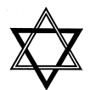
The Seal Of The Theosophical Society
The Interlaced Triangles
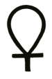
Sign of Vishnu; Solomon's Seal. The symbolical double triangle, adopted by the T.S. and by many Theosophists. Why it should be called “Solomon’s Seal” is a mystery, unless it came to Europe from Iran, where many stories are told about that mythical personage and the magic seal used by him to catch the djins and imprison them in old bottles. But this seal or double triangle is also called in India the “Sign of Vishnu”, and may be seen on the houses in every village as a talisman against evil. The triangle was sacred and used as a religious sign in the far East ages before Pythagoras proclaimed it to be the first of the geometrical figures, as well as the most mysterious. It is found on pyramid and obelisk, and is pregnant with occult meaning, as are, in fact, all triangles. Thus the pentagram is the triple triangle‎—‎the six-pointed being the hexalp ha. The way a triangle points determines its meaning. If upwards, it means the male element and divine fire; downwards, the female and the waters of matter; upright, but with a bar across the top, air and astral light; downwards, with a bar‎—‎the earth or gross matter, etc., etc. When a Greek Christian priest in blessing holds his two fingers and thumb together, he simply makes the magic sign‎—‎by the power of the triangle or “trinity”.
The Cross
Ankh; Crux Andata; Calvary Cross. This form of cross does not date from Christianity. It was known and used for mystical purposes, thousands of years before our era. It formed part and parcel of the various Rituals, in Egypt and Greece, in Babylon and India, as well as in China, Mexico, and Peru. It is a cosmic, as well as a physiological (or phallic) symbol. That it existed among all the heathen” nations is testified to by Tertullian. “How doth the Athenian Minerva differ from the body of a cross?” he queries. “The origin of your gods is derived from figures moulded on a cross. All those rows of images on your standards are the appendages of crosses; those hangings on your banners are the robes of crosses.” And the fiery champion was right. The tau or T is the most ancient of all forms, and the cross or the tat (q.v.) as ancient: The crux ansata, the cross with a handle, is in the hands of almost every god, including Baal and the Phœnician Astarte. The croix cramponnée is the Indian Szoastica. It has been exhumed from the lowest foundations of the ancient site of Troy, and it appears on Etruscan and Chaldean relics of antiquity. As Mrs. Jamieson shows: “The ankh of Egypt was the crutch of St. Anthony and the cross of St. Philip. The Labarum of Constantine . . was an emblem long before, in Etruria. Osiris had the Labarum for his sign; Horns appears sometimes with the long Latin cross. The Greek pectoral cross is Egyptian. It was called by the Fathers ‘the devil’s invention before Christ’. The crux ansata is upon the old coins of Tarsus, as the Maltese upon the breast of an Assyrian king. The cross of Calvary, so common in Europe, occurs on the breasts of mummies. It was suspended round the necks of sacred Serpents in Egypt. Strange Asiatic tribes bringing tribute in Egypt are noticed with garments studded with crosses, and Sir Gardner Wilkinson dates this picture B.C., 1500.” Finally, “Typhon, the Evil One, is chained by a cross!” (Eg. Belief and Mod. Thought).
The crux ansata was the foremost symbol in the Egyptian Masonry instituted by Count Cagliostro, and Masons must have indeed forgotten the primitive significance of their highest symbols, if some of their authorities still insist that the crux ansata is only a combination of the cteis (or yoni) and phallus (or lingham). Far from this. The handle or ansa had a double significance, but never a phallic one; as an attribute of Isis it was the mundane circle; as a symbol of law on the breast of a mummy it was that of immortality, of an endless and beginningless eternity, that which descends upon and grows out of the plane of material nature, the horizontal feminine line, surmounting the vertical male line the fructifying male principle in nature or spirit. Without the handle the crux ansata became the tau T, which, left by itself, is an androgyne symbol, and becomes purely phallic or sexual only when it takes the shape +.
The Circle and Serpent

Circle. There are several “Circles” with mystic adjectives attached to them. Thus we have: (1) the “Decussated or Perfect Circle” of Plato, who shows it decussated in the form of the letter X; (2) the “Circle-dance” of the Amazons, around a Priapic image, the same as the dance of the Gopis around the Sun (Krishna), the shepherdesses representing the signs of the Zodiac ; (3) the “Circle of Necessity” of 3,000 years of the Egyptians and of the Occultists, the duration of the cycle between rebirths or reincarnations being from 1,000 to 3,000 years on the average.
Serpent, swallowing its tail
The simile of an egg also expresses the fact taught in Occultism that the primordial form of everything manifested, from atom to globe, from man to angel, is spheroidal, the sphere having been with all nations the emblem of eternity and infinity—a serpent swallowing its tail. To realize the meaning, however, the sphere must be thought of as seen from its centre. The field of vision or of thought is like a sphere whose radii proceed from one’s self in every direction, and extend out into space, opening up boundless vistas all around. It is the symbolical circle of Pascal and the Kabalists, “whose centre is everywhere and circumference nowhere,” a conception which enters into the compound idea of this emblem.
The “Mundane Egg” is, perhaps, one of the most universally adopted symbols, highly suggestive as it is, equally in the spiritual, physiological, and cosmological sense. Therefore, it is found in every world-theogony, where it is largely associated with the serpent symbol; the latter being everywhere, in philosophy as in religious symbolism, an emblem of eternity, infinitude, regeneration, and rejuvenation, as well as of wisdom. (See Part II. “Tree and Serpent and Crocodile Worship.”) The mystery of apparent self-generation and evolution through its own creative power repeating in miniature the process of Cosmic evolution in the egg, both being due to heat and moisture under the efflux of the unseen creative spirit, justified fully the selection of this graphic symbol. The “Virgin Egg” is the microcosmic symbol of the macrocosmic prototype—the “Virgin Mother”—Chaos or the Primeval Deep. The male Creator (under whatever name) springs forth from the Virgin female, the immaculate root fructified by the Ray. Who, if versed in astronomy and natural sciences, can fail to see its suggestiveness? Cosmos as receptive Nature is an Egg fructified—yet left immaculate; once regarded as boundless, it could have no other representation than a spheroid. The Golden Egg was surrounded by seven natural elements (ether, fire, air, water), “four ready, three secret.”
The serpent is a sacred symbol, basis of Python or Pythagoras (Gr.). The most famous of mystic philosophers, born at Samos, about 586 B.C. He seems to have travelled all over the world, and to have culled his philosophy from the various systems to which he had access. Thus, he studied the esoteric sciences with the Brachmanes of India, and astronomy and astrology in Chaldea and Egypt. He is known to this day in the former country under the name of Yavanâchârya (“Ionian teacher”). After returning he settled in Crotona, in Magna Grecia, where he established a college to which very soon resorted all the best intellects of the civilised centres. His father was one Mnesarchus of Samos, and was a man of noble birth and learning. It was Pythagoras who was the first to teach the heliocentric system, and who was the greatest proficient in geometry of his century. It was he also who created the word “philosopher”, composed of two words meaning a “lover of wisdom”‎—‎philo-sophos. More especially, “Wisdom of Love”. As the greatest mathematician, geometer and astronomer of historical antiquity, and also the highest of the metaphysicians and scholars, Pythagoras has won imperishable fame. He taught reincarnation as it is professed in India and much else of the Secret Wisdom.
A variant of the serpent is Pythia or Pythoness (Gr.). On the authority of Iamblichus, Plutarch and others, a Pythia was a priestess chosen among the sensitives of the poorer classes, and placed in a temple where oracular powers were exercised. There she had a room secluded from all but the chief Hierophant and Seer, and once admitted, was, like a nun, lost to the world. Sitting on a tripod of brass placed over a fissure in the ground, through which arose intoxicating vapours, these subterranean exhalations, penetrating her whole system, produced the prophetic mania, in which abnormal state she delivered oracles. Aristophanes in “Væstas” I., reg. 28, calls the Pythia ventrilogua vates or the “ventriloquial prophetess”, on account of her stomach-voice. The ancients placed the soul of man (the lower Manas) or his personal self-consciousness, in the pit of his stomach. We find in the fourth verse of the second Nâbhânedishta hymn of the Brahmans: “Hear, O sons of the gods, one who speaks through his name (nâbhâ), for he hails you in your dwellings! “This is a modern somnambulic phenomenon. The navel was regarded in antiquity as “the circle of the sun”, the seat of divine internal light. Therefore was the oracle of Apollo at Delphi, the city of Delphus, the womb or abdomen‎—‎while the seat of the temple was called the omphalos, navel. As well-known, a number of mesmerized subjects can read letters, hear, smell and see through that part of their body. In India there exists to this day a belief (also among the Parsis) that adepts have flames in their navels, which enlighten for them all darkness and unveil the spiritual world. It is called with the Zoroastrians the lamp of Deshtur or the “High Priest,”; and the light or radiance of the Dikshita (the initiate) with the Hindus.
Nâga (Sk.), Literally “Serpent”. The name in the Indian Pantheon of the Serpent or Dragon Spirits, and of the inhabitants of Pâtâla, hell. But as Pâtâla means the antipodes, and was the name given to America by the ancients, who knew and visited that continent before Europe had ever heard of it, the term is probably akin to the Mexican Nagals the (now) sorcerers and medicine men. The Nagas are the Burmese Nats, serpent-gods, or “dragon demons”.
In Esotericism, however, and as already stated, this is a nick-name for the “wise men” or adepts. In China and Tibet, the “Dragons” are regarded as the titulary deities of the world, and of various spots on the earth, and the word is explained as meaning adepts, yogis, and narjols. The term has simply reference to their great knowledge and wisdom. This is also proven in the ancient Sûtras and Buddha’s biographies. The Nâga is ever a wise man, endowed with extraordinary magic powers, in South and Central America as in India, in Chaldea as also in ancient Egypt. In China the “worship” of the Nâgas was widespread, and it has become still more pronounced since Nâgârjuna (the “great Nâga”, the “great adept” literally), the fourteenth Buddhist patriarch, visited China. The “Nâgas” are regarded by the Celestials as “the tutelary Spirits or gods of the five regions or the four points of the compass and the centre, as the guardians of the five lakes and four oceans” (Eitel). This, traced to its origin and translated esoterically, means that the five continents and their five root-races (streams of consciousness) had always been under the guardianship of “terrestrial deities”, i.e., Wise Adepts. The tradition that Nâgas washed Gautama Buddha at his birth, protected him and guarded the relics of his body when dead, points again to the Nagas being only wise men, Arhats, and no monsters or Dragons. This is also corroborated by the innumerable stories of the conversion of Nagas to Buddhism. The Nâga of a lake in a forest near Râjagriha and many other “Dragons” were thus converted by Buddha to the good Law.
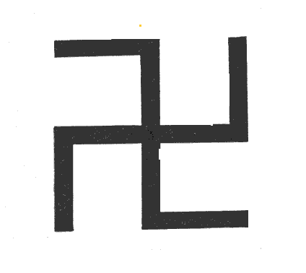
Svastika
Flaming Cross or Svastika (Sk.). In popular notions, it is the Jaina cross, or the “four-footed” cross (croix cramponnée). In Masonic teachings, “the most ancient Order of the Brotherhood of the Mystic Cross” is said to have been founded by Fohi, 1,027 B.C., and introduced into China fifty-two years later, consisting of the three degrees. In Esoteric Philosophy, the most mystic and ancient diagram. It is “the originator of the fire by friction, and of the ‘Forty-nine Fires’.” Its symbol was stamped on Buddha’s heart, and therefore called the “Heart’s Seal”'. It is laid on the breasts of departed Initiates after their death; and it is mentioned with the greatest respect in the Indian epic, the Râmâyana. Engraved on every rock, temple and prehistoric building of India, and wherever Buddhists have left their landmarks; it is also found in China, Tibet and Siam, and among the ancient Germanic nations as Thor's Hammer. As described by Eitel in his Hand-Book of Chinese Buddhism; (1) it is “found among Bonpas and Buddhists”; (2) it is “one of the sixty-five figures of the Sripâda”; (3) it is “the symbol of esoteric Buddhism”; (4) “the special mark of all deities worshipped by the Lotus School of China”. Finally, and in Occultism, it is as sacred as the Pythagorean tetraktys, of which it is indeed the double symbol.
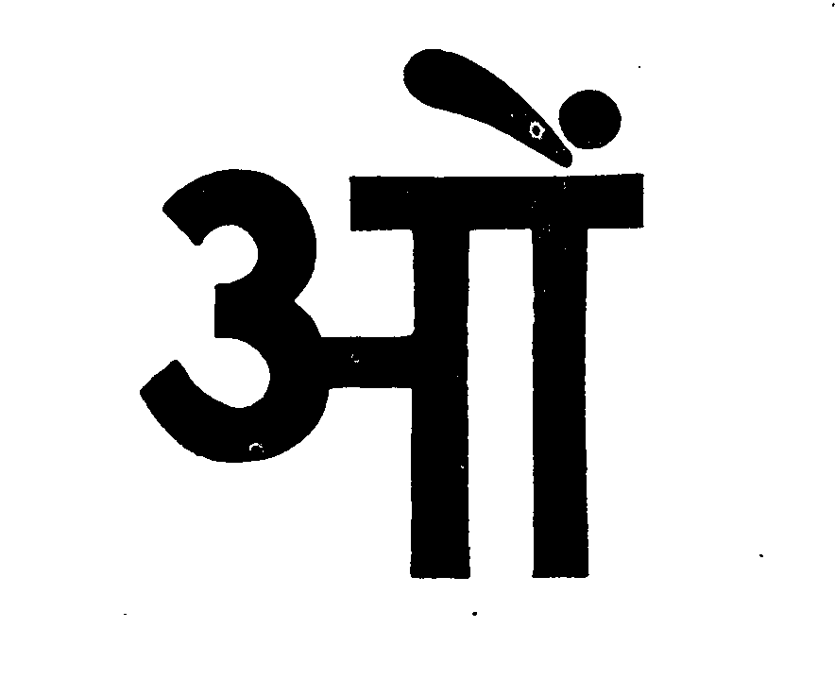
Aum or Om or Sacred Word
Om or Aum (Sk.). A mystic syllable, the most solemn of all words in India. It is “an invocation, a benediction, an affirmation and a promise”; and it is so sacred, as to be indeed the word at low breath of occult, primitive masonry. No one must be near when the syllable is pronounced for a purpose. This word is usually placed at the beginning of sacred Scriptures, and is prefixed to prayers. It is a compound of three letters a, u, m, which, in the popular belief, are typical of the three Vedas, also of three gods—A (Agni) Y (Varuna) and M (Maruts) or Fire, Water and Air. In esoteric philosophy these are the three sacred fires, or the “triple fire” in the Universe and Man, besides many other things. Occultly, this “triple fire” represents the highest Tetraktys also, as it is typified by the Agni named Abhimânim and his transformation into his three sons, Pâvana, Pavamâna and Suchi, “who drinks up water”, i.e., destroys material desires. This monosyllable is called Udgîtta, and is sacred with both Brahmins and Buddhists.
Arthur M Coon suggests “the Sanskrit word AUM passed from India into Egypt. There the spelling was slightly changed—the AUM becoming AMN. This name was applied to the Hidden God‎—‎the Illimitable, the ultimate, the Eternal God of Light ‘Amen-Ra’. This Word, as well as something of its divine significance, was in time appropriated by the Hebrews, and ‘O-MN’ pronounced ‘O-mein’ became the sacred oath or invocation to the ‘Hidden God’. This same word changed to ‘AMEN’ is to this day used at the end of every Christian hymn and to close, as with the seal of Truth, every prayer.”
SATYÂT NÂSTI PARO DHARMAH
There is no Religion higher than Truth

